10.04
Part Request Fulfilment
Process Design & AMOS Configuration Document
Purpose
This Process Design document is provided to Key-Users to record their key decisions regarding the AMOS Process design and the required AMOS configuration.
It is updated throughout the Project Definition Phase and used as the baseline for the Final Acceptance prior to Go-Live
Revision
Author, Name | Date | Notes
Paulo Reuter Perine | 01.06.2024 | First version

Table of Contents
1. Process Overview & Objectives 3
2. Regulatory References 3
3. Definitions & Glossary 3
4. Process Tasks 4
5. Process Dependencies 4
6. Process Flow 6
7. Process Design Questions 7
8. Data Source Mapping 9
9. Other Software Used 9
10. AMOS Configuration 9
a. Process specific configuration programmes 9
b. Basic Data 9
c. Parameters 9
d. Workflows 11
e. Scheduled Tasks 11
f. API’s & Interfaces 11
11. UAT Guidance 12
12. Annex – Additional Info 12

Process Overview & Objectives
Process General Description:
This process outlines the steps for fulfilling a part request originating from a maintenance event on an aircraft or during maintenance performed at a component shop. The task flow encompasses all necessary actions to fulfil the part request, starting from the creation of the pickslip until the part is either installed on the aircraft or consumed for maintenance purposes. If the material is not required for maintenance, the process also includes the return of the part to the stores.
Main Process Objective (Outputs & Outcomes):
This process has two primary objective and they are: to ensure material usage traceability; and to maintain precise stock levels. To achieve this, each request for material from the store and subsequent returns are meticulously managed using pickslips and pickinglists. These pickslips and pickinglists serve as essential documents that facilitate the tracking and control of material movement within the organization.
Material Usage Traceability:
- The process aims to establish a clear trail of material usage. By associating each transaction with a pickslip, the organization can trace the movement of materials from the store to their final destination (such as installation on an aircraft or consumption during maintenance).
- This traceability is crucial for quality control, compliance, and auditing purposes. It ensures that materials are used appropriately and can be accounted for at every stage.
- Whether a part is picked for maintenance, repair, or replacement, the pickslip provides a record of its journey.
Accurate Stock Level Maintenance:
- Effective stock management relies on accurate data. Pickslips and pickinglists play a pivotal role in maintaining precise stock levels.
- When a request for material is initiated, the pickslip captures relevant details such as the requested item, quantity, and purpose. This information allows the organization to adjust stock levels accordingly.
- Similarly, when material is returned to the store (e.g., if it was not needed for maintenance), the pickslip and pickinglist ensures that the stock inventory is updated accurately.
- By organizing pickslips into Picking Lists, the process optimizes the picking requests. Items are grouped logically, streamlining the picking process for stores.
In summary, pickslips and pickinglists serve as the backbone of material management, promoting transparency, accountability, and efficient stock control.

Regulatory References
There is no worldwide authority regulation applicable to this process.

Definitions & Glossary
Key-Words | Explanation
AME | AMOSmobile/EXEC.
AMS | AMOSmobile/STORES.
APN | AMOS Program Number.
CMWP | Component Maintenance Workpackage created in AMOS.
Desktop | AMOSdesktop client.
WP | Aircraft Workpackage created in AMOS.

Process Tasks
Business Process Task / Actions / Activities:
- Configure self-picking: To facilitate the overall process of picking parts in a store and issuing a pickslip for them, by allowing the system to manage some of the steps, such as creating the pickslip request and confirmation. Because of this simplification, various checks and validations have been setup on the fields and actions to make sure the self-picking process runs smoothly. Once self-picking is configured and enable the mechanic can issue a part request, the system will then generate a pickslip automatically and the mechanic himself can go where the part is available and self-pick the part using APN 2587 Self Picking. The mechanic can only self-pick parts for workorder or a maintenance event.
- Define picking list rules: Before starting the picking process, all pickslips generated in the system need to be assigned to a picking list. This assignment of pickslips to pickinglists can be tailored based on company needs. The ruleset needs to be created on APN 2605 Store Configuration.
- Define pickslip booking levels (drop, transit, book): When a pickinglist is issued to pick parts to fulfil pickslips (part request) AMOS supports different types of transactions and states that can be tailored to create the material traceability that is needed. By configuring access rights for APN 2612 Picking List Management and defining related parameters on APN 1442 Parameter Setup properly it is possible to customize the storemen experience and record only the transactions that are needed to fulfil company policy.
- Return parts: If unused parts need to be returned to store, the Return process can be initiated by the storemen from APN 2612 Picking List Management. The storemen will identify the part, locate the Picking List the delivered the part to the mechanic, cancel the pickslip, and move the part back to store location.
- Define corresponding location types (return, drop, transit): To better organize your store, you can define location to handle material that are in different stages of the picking process. This location will help you to identify and know where the part is going to be. If the part is being returned: if it is waiting the mechanic to collect; or if it is in transit inside the store (still being picked by the storemen).

Process Dependencies
INPUT | CONCURRENT | OUTPUT
- 03.01 – Planning: Define scope of work and issue pickslip for a WP.  - 03.02 – Work Package Generation: Define and fine tune the scope of work and issue pickslip for a WP.  - 07.06 – Customer MRO Work Packages: Define the scope of work and issue a pickslip for a CMWP.  - 08.02 – Performing Maintenance: Perform maintenance and issue part requests for the parts that are needed but not yet delivered to execute the work by issuing a pickslip.  - 09.03 – Ordering: Issue an Order that requires material to be collected from Stores to be sent externally.  - 09.06 – Pooling and Consignment: Issue an Order that requires pool or consignment parts to be picked from stores.  - 09.07 – Outstations and MROs: Transfer material to another Station to an MRO.  - 10.02 – Goods Receiving & Inspection: Receiving of material and parts and move to stores.  - 10.03 – Major Assemblies: Receiving of major assemblies and move to stores.  - 11.03 – Shop Planner: Define scope of work and issue pickslip for a CMWP.  - 11.04 – Component Maintenance: Perform maintenance and issue part requests for the parts that are needed but not yet delivered to execute the work by issuing a pickslip. | - 10.04 – Part Request Fulfilment: Drop, Deliver, Book, transfer parts out of store. Return non used parts back to stores. | - 08.02 – Performing Maintenance: Workorder or maintenance event is performed using the material fulfilled by stores.  - 08.04 – Parts Removal & Installation: Install part in the aircraft.  - 11.04 – Component Maintenance: Performing Maintenance: Workorder or maintenance event is performed using the material fulfilled by stores.

Process Flow
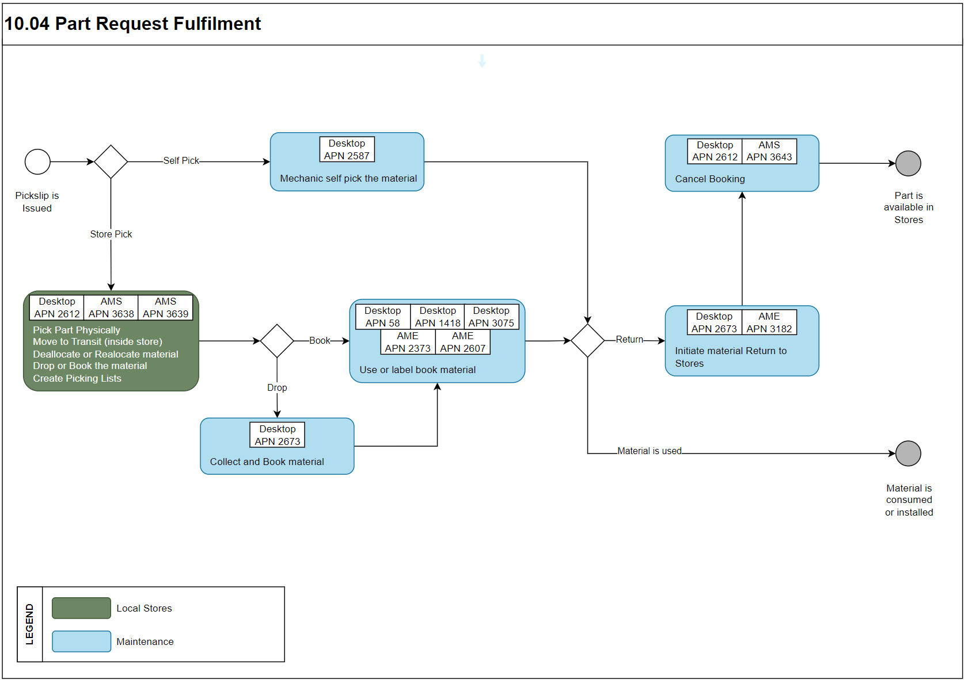

Process Design Questions
# | Question | Answer
1 | What will be the Pickslip request process for scheduled work packages? Who issues the Pickslip requests?  Typically, the planner will issue the Pickslip request for scheduled work packages.
2 | How many days in advance will the Pickslips for a work package be issued to the store?
3 | How is the material handed over to production? Is there a designated area? Is it sorted by event or by A/C Registration?
4 | What will be the Pickslip request process for unscheduled work?  Who issues the Pickslip requests?  Typically, the mechanic will issue the Pickslips request themselves.
5 | Tools can be issued from stock by using Pickslips, but the standard process is not to use Pickslips for tools but to use Tool Registration (APN: 410).  Will Pickslips be issued for tool P/N’s?
6 | Should the Receiver be a mandatory field in the Pickslip Request (APN: 225)? Set parameter 1423. Recommendation is “Yes”. The Receiver is either an aircraft or a department cost center.
7 | Should the Project no. be a mandatory field in the Pickslip Request (APN: 225)? Set Parameter 882.  If the project no. field is mandatory, should the status of the project no. be checked for validity against the W/O. Set Parameter 1283.
8 | Should the Workorder No. be a mandatory field in the Pickslip Request (APN: 225)? Set parameter 904. Recommendation is Yes.
9 | Should a display message inform the user if a Pickslip P/N has already been requested X times within the last Y days for the same aircraft? Recommendation “No”.  Set Parameter 1121 and Parameter 1122.
10 | Is restricted access logic used for certain user logins?  E.g., some do some user-logins only have access to data for aircraft “Operated by:” or “Maintained by:” as defined in Admin Logins (APN: 14).  If yes, then set parameter 1423 to restrict the Pickslip Viewer (APN: 375) search filters.
11 | How should Requests be handled when there is not sufficient stock? Cancel the request, keep the request open?
12 | Which documentation should be handed out with the parts? Certificate copies for consumables? Return Slips for all parts?
13 | Should there be a restriction for certain users not to issue Pickslip requests for parts above a certain average price?  E.g., do not allow all users to issue a Pickslip for an APU.  If “Yes”, then activate the Workflow “Stop processing Pickslip Request. Template Rule-ID103” with the wildcard “max_average_price”?
14 | Will the mechanics be responsible to book the parts into consumption when they are used, or should they be booked to consumption as soon as the leave the store?

Data Source Mapping
Data Sources | Description | Volume / Manual / Automatic / Static / Dynamic
-/- | -/- | -/-

Other Software Used
Other Software | Used by: | Description
-/- | -/- | -/-

AMOS Configuration

Process specific configuration programmes
AMOS APN | Notes
APN 612 Workflow | Configure workflows (e.g. inform if part is booked)
APN 2409 Store Management | Define Drop and Transit locations.
APN 2605 Store Configuration | Set Pickslip Issue, Pickslip Assign and Picking List Issue rules.
APN 2606 Scheduler Task | Set Pickslip Issue and Picking List Issue task.

Basic Data
Basic Data Table | Notes
-/- | -/-

Parameters
Parameter Code | Parameter Name | Notes
802 | SAVE PICKSLIP AS PDF | Print Pickslip  Don't print the Pickslip. Only print the picking list. Enter a folder directory on the server where to save the Pickslips. | String 2
882 | PROJECTNO MANDATORY IN PICKSLIP | Allow unknown Workorders on Pickslips  It will allow requesting parts for a Workorder which does not yet exist in AMOS. E.g. Techlog Number. As soon as the Workorder is created the part requests are shows as "additional requests" on the Workorder.  Set default value of Project  Set mandatory if Project Numbers are used for financial purposes  Set to default project number of Workorder and allow to be changed  Check Status and valid period of project | Float 1.00;  Integer 0;  String Y
904 | CHECK WORKORDERNO IN PICKSLIP | Check Workorder Number  Don't check Workorder Number to allow issuing Pickslip for Pre-Printed Techlog-Numbers | Float 1.0; Integer 1;  String N
1397 | USE TOOL LOGIC FOR LOCAL PICKSLIPS | Use Tool logic  For individual requests don't issue a Pickslip, use tool registration for handout.  For planned events use separate Pickslip for tools in order to prepare required tooling before the start of the event. | String Y
1423 | PICKSLIP RECEIVER AND MC RESTRICTION | Receiver mandatory  Set to yes as mostly required for financial purposes | Float 1.0;  String Y
1676 | AUTOMATIC DROP | Drop Off Location  Set as Mandatory to specify where parts should be delivered, don't?t set to "Drop" automatically to force user to make a decision in case many drop locations exists. | Integer 1;  String Y
1680 | Assign pickslips to pickinglists | Assign to Picking Lists  Required to assign to use Picking Lists | String Y
1685 | Pickslip splitting logic | Split Pickslips per Workstep  Items will be assigned to picking lists according to rules. Only relevant if material should be consolidated by Pickslip Number | String N

Workflows
Workflow Number | Workflow Name | Workflow Setup Notes
99 | Part with remarks entered into pickslip | Can be used to show a pop-up with "Pickslip Remarks" if available for the part requested in APN 59 Part Administration.
103 | Pickslip sent to store will be stopped | Can be used to stop users from issuing Pickslips.
376 | Picking List | Controls which actions should be taken after a Picking List is assigned or set to a different status. E.g. Print or inform user by workflow or email/SMS.
381 | Picking List item | Controls which actions are allowed in Picking List Management.
387 | Issue Entity Sales Transaction | Can be used to create a sales booking if a part from a different entity/owner is picked.

Scheduled Tasks
Scheduled Task Reference | Frequency | Notes
IssueAutomaticPickslipService | Depending how many times per day Pickslips should be issued:  once/day, once/shift | Active if Pickslips should be issued automatically based on the rules.  Number of days in the future: depending on how long in the future Pickslips should be issued. Recommendation: 1 day  Process only forecast events with Workorder, assigned to Workpackage, or whom the Workpackage has been modified: Set to Yes to use it only for planned events.
IssuePickingListService | Every 1-5 minutes | Active if Picking Lists should be issued automatically based on the rules.  Consider all rule ID's.

API’s & Interfaces
Reference | Direction | Trigger | Frequency
-/- | -/- | -/- | -/-

UAT Guidance
Test case number | Test case description | Required data | Required resources
01 | Issue a part request for a maintenance event. | Workorder with a part request. | Mechanic
02 | Monitor if the Pickslip is issued automatically per the scheduler task. | -/- | Storemen
03 | Monitor if the pickslip is assigned to a Picking List and if the Picking List is issued for collection. | -/- | Storemen
04 | Assign the Picking List to a storemen. | -/- | Storemen
05 | Storemen picks all parts from the picking list and move to transit location. | -/- | Storemen
06 | Once all parts are picked, storemen move the items to their respective drop locations. | -/- | Storemen
07 | Once the process is complete, return part not used. | P/N to be returned. | Mechanic and/or Storemen

Annex – Additional Info
-/-

